beautiful addiction
All Words & Music: © Darren Poyzer . www.poyzer.com . tel 07866 507441
How can you say you love somebody, more than someone you love?
How can you make a decision like this, when your head is so full of that crazy stuff?
I guess we're doing well but we, could do better
Stories we could tell of times, we've been nailed together
These are times that make the man
The man is living on the edge
He gets his fix as best he can
My beautiful, my beautiful, addiction
Remembering how we all sang 'Feed The World'
A harmony heaven sent
I never realised how far we'd been sold
Until we voted for this Government
These are times that make the woman
The woman is living on the edge
She gets her fix as best she can
My beautiful, my beautiful, addiction
And she's killing me with kindness
A subtle blend of silence
Alternatives to violence
That know no rules
I respect her and enjoy her
She cures my paranoia
And I'm the happiest of fools
I'm the happiest of fools
~ ~ ~
beautiful addiction
All Words & Music: © Darren Poyzer . www.poyzer.com . tel 07866 507441
Guitar chord shapes used in this song:
(‘Drop D’ tuning / I play this with Capo 2nd Fret)

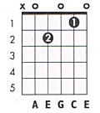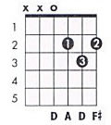
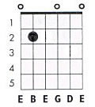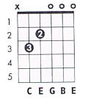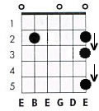

I play the two opening chords and intro sequence using inversions on the 7th and 5th frets. May be best to see the video on the website to fully get to grips with this.

The ‘cheat’ version uses the above D shapes and Am7 for verse, and Em7 / Cmaj7 / D shapes, with a couple of intricate things that again are probably best explained on the video.

~ ~ ~

‘Beautiful Addiction’ was first recorded for the ‘Passion And Conflict’ album and later on the ‘Global’ DVD & CD.

These chords and lyrics compliment the Songbook video at www.poyzer.com

